Research design settings

## Fonts

* Best universal fonts and accessibility. Fonts with simple, familiar shapes are generally easier to read.
  + Sans-serif fonts (no decorative strokes at the end of each letter):
    - Georgia (Gelasio for Google)
    - Helvetica (Open Sans for Google, Arial for Windows)

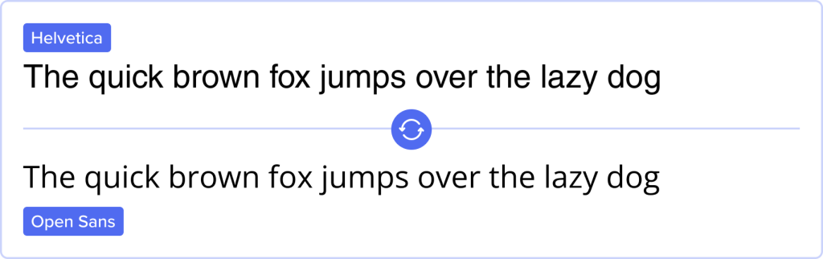

* Font size recommendations
  + Providing controls that allow users to incrementally change the size of all text up to 200 percent (check that after increasing the text size to 200% of the original size, there is no loss of content or functionality).
  + When a user adapts the page to increase the text spacing, text fits within the bounds of its containing box.
  + Bulleted and numbered lists are a very good way to present list content and set points apart.
  + Font sizes should never be less than the equivalent of 12 pixels.
  + Minimize inappropriate use of bold and italic fonts and also all-caps fonts are almost never appropriate and are very hard for some people to read.
  + Make sure there is enough spacing between characters.
  + As a rule, the line spacing should be set to the font size +6pt.
* Contrast and legibility. Make certain that product has good contrast. Contrast is the difference in color or density between the background and foreground (black on white is an example of good contrast, while purple on dark blue would surely result in poor contrast).
  + Links with a 3:1 contrast ratio with surrounding text with a white background. A blue color is recommended because it is affected very little by red and green color blindness  (example).

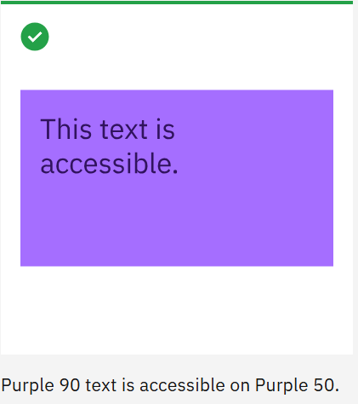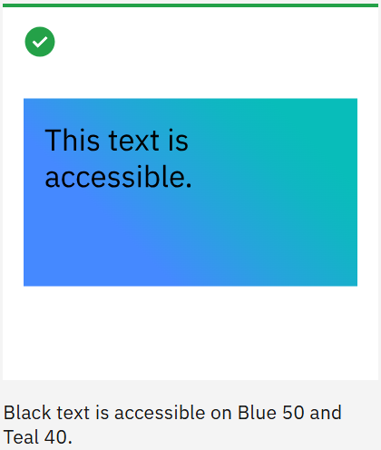

* + Text presented in an image is not accessible and must be described.
  + Animated (moving, wavy, blinking, etc.) text certainly needs to be avoided.

Color palettes

* Colorblind-friendly color schemes
  + Calm colors
    - Dark Blue: #332288
    - Green: #999933
    - Teal: #88CCEE
    - Light Blue: #44AA99
    - Yellow: #DDCC77
    - Orange: #117733
    - Pink: #CC6677
    - Purple: #AA4499
    - Maroon: #882255

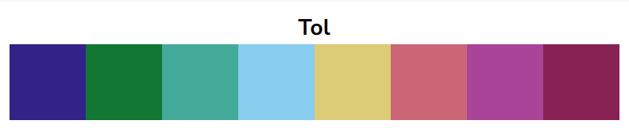

* + - Background Colors
      * Dark blue, teal, light blue - provides a neutral and calming base, a soft and non-distracting look, gentle and clear base.
    - Icon Colors
      * Yellow, pink, orange - stand out well against darker backgrounds, drawing attention effectively.
      * Purple: Works well for icons, providing good visibility against lighter backgrounds.
    - Text Colors
      * Black: Best for text on lighter backgrounds, ensuring high readability.
      * White: Ideal for text on darker backgrounds, providing clear contrast.
    - Accent Colors
      * Green: Can be used for highlights and important areas, offering good visibility.
      * Maroon: Suitable for accents, providing a strong contrast.
  + Pairs:

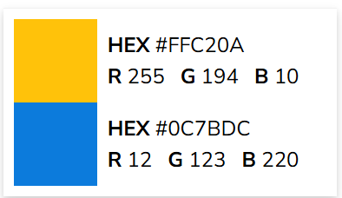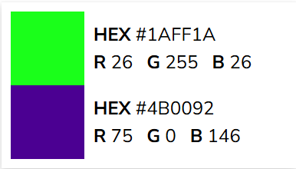

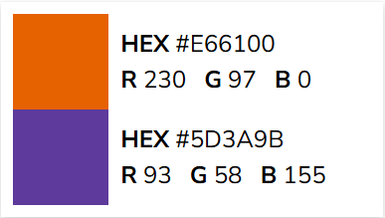

* High contrast color palettes

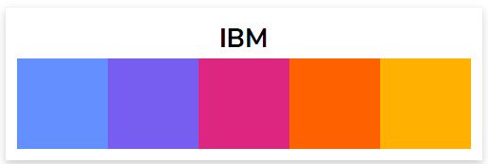

* + Blue (#648FFF): ideal for backgrounds and large areas due to its calming and neutral properties.
  + Purple (#785EF0): suitable for accents and highlights, as it stands out well against both light and dark backgrounds.
  + Pink (#DC267F): perfect for icons and important elements that need to draw attention.
  + Orange (#FE6100): great for icons and call-to-action elements, as it is vibrant and eye-catching.
  + Yellow (#FFB000): works well for highlights and accents, providing a bright and noticeable contrast.
  + White (#FFFFFF): best used for text and icons on dark (purple, orange) backgrounds, ensuring high readability.
  + Black (#000000): ideal for text and icons on light (blue, pink, yellow) backgrounds, providing clear and strong contrast.
* Avoiding problematic color combinations

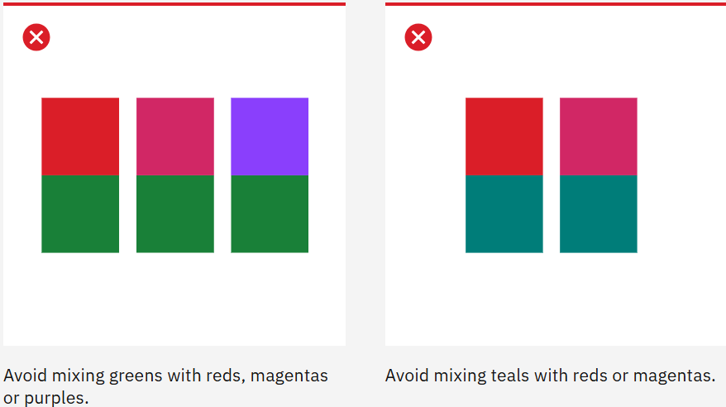

* Using patterns and textures
  + Do not contain anything that flashes more than three times in any one second period (not to cause seizures or physical reactions)

## Icons

* Icon sizes for accessibility
  + Clickable icon should be at least 24×24 pixels
* Contrast and visibility of icons
  + Have widely used colors for almost immediate understanding of content of icon (for example red for canceling/deleting/exiting/invalid and green for go/okay/agree/valid buttons) (W3.org., 2024). But the product shouldn’t only rely on colors, the appropriate description is required (Riley-Huff, 2012).
* Icons for screen readers
  + Add tags to icons for screen readers to access

## References

W3.org. (2024). Securely - Geolocation sharing. [online] Available at: <https://www.w3.org/WAI/WCAG22/quickref/?showtechniques=134%2C141#use-of-color> [Accessed 5 Dec. 2024].

Riley-Huff, D.A. (2012). Chapter 4: Web Accessibility and Universal Design. Library Technology Reports, [online] 48(7), pp.29–35. Available at: <https://journals.ala.org/index.php/ltr/article/view/4687/5575>.

Scope (2019). Home | Disability charity Scope UK. [online] Scope. Available at: <https://www.scope.org.uk/>.

Ibm.com. (2020). IBM Design Language – Color. [online] Available at: <https://www.ibm.com/design/language/color/>.

Nichols, D. (n.d.). Coloring for Colorblindness. [online] www.davidmathlogic.com. Available at: <https://davidmathlogic.com/colorblind/#%23648FFF-%23785EF0-%23DC267F-%23FE6100-%23FFB000>.

Collective, T.A. (2023). Improving Icon Usability and Accessibility: 6 Valuable Tips. [online] The A11Y Collective. Available at: <https://www.a11y-collective.com/blog/icon-usability-and-accessibility/>.